|  |
| --- |
| SCREEN SEQUENCE DIAGRAMS |



FLEX: SCHEDULING APPLICATION

# 

# 

SAN DIEGO SOFTWARE

JANUARY 27, 2017

|  |  |  |
| --- | --- | --- |
| **Orr Yakobi**, Project Manager  **Aidan Keogh**, Software Dev Lead  **Amanda Smith**, UI Specialist | **Anand Kumar**, Senior System Analyst  **Oliver Ganguli**, Database Specialist  **Steven Lay**, Business Analyst | **Tal Ben-Ari**, Software Architect  **Abram Trinh**, Quality Assurance  **Matt Olsen**, Database Specialist |

# Overview

## **User Account Management (UA)**

1. Login
2. Logout

## **Task List Management (TM)**

1. Create Task
2. Modify Task
3. Delete Task
4. Task Completion
5. Task Scheduling

## **Task View (TV)**

1. View Tasks
2. Sort Tasks
3. Filter Tasks
4. Task Search

## **Calendar View (CV)**

1. View Calendar
2. Event Search
3. Task Details

## **Settings Page (SP)**

1. View Settings
2. Update Settings

## **User Support (US)**

1. Access Help Page
2. Contact Customer Support

# 

# 

# References

## **Task/Event Fields (REF 01):**

1. Description
2. Priority
3. Date
4. Time
5. Location
6. Duration
7. Recurring Task/Not Recurring Task
8. Flexibility

## **Calendar Fields (REF 02):**

1. Description
2. Color
3. Priority

## **Database Models (REF 03): (directory : sds-webapp/server/models/)**

1. User
2. Group
3. Calendar
4. Task

## **HTML pages (REF 04):**

1. o-Auth.html
2. calendar.html
3. task.html
4. settings.html
5. help.html

# User Login [UA 01]

Back To Overview

UA01-02.png

# 

# 

# User Logout [UA 02]

Back To Overview

UA02.png

# 

# 

# Create Task [TM 01]

Back To Overview

TM01.png

# 

# Modify Task [TM 02]

Back To Overview

TM02.png

# 

# Delete Task [TM 03]

Back To Overview

TM03.png

# 

# Task Completion [TM 04]

Back To Overview

TM04.png

# 

# Task Scheduling [TM 05]

Back To Overview

TM05.png

# View Tasks [TV 01]

Back To Overview

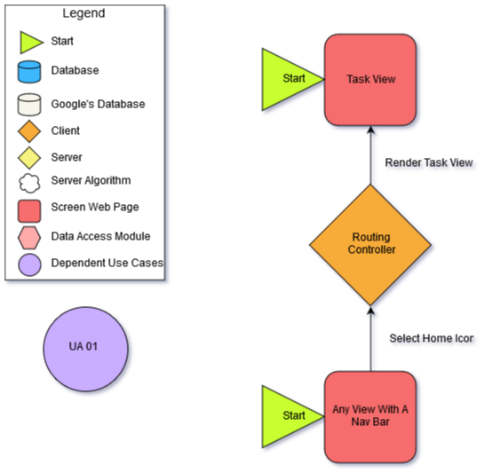

# 

# Sort Tasks [TV 02]

Back To Overview

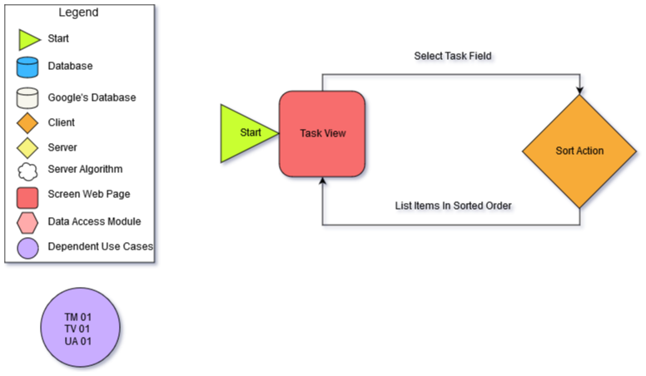

# Filter Tasks [TV 03]

Back To Overview

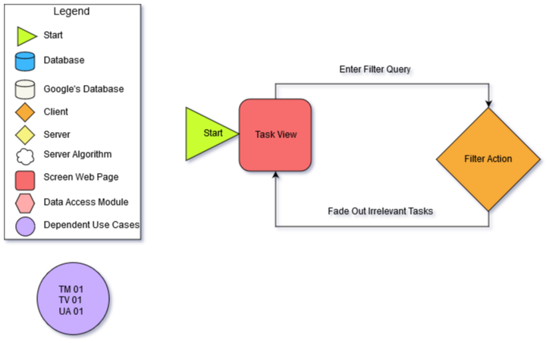

# 

# Task Search [TV 04]

Back To Overview

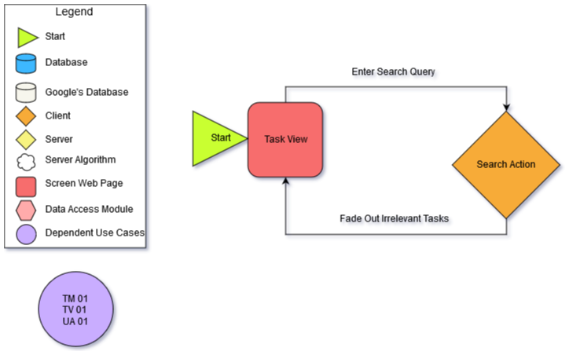

# View Calendar [CV 01]

Back To Overview

CV01.png

# 

# 

# Event Search [CV 02]

Back To Overview

CV02.png

# Task Details [CV 03]

Back To Overview

CV03.png

# 

# View Settings [SP 01]

Back To Overview

SP01.png

# Update Settings [SP 02]

Back To Overview

SP002.png

# 

# Access Help Page [US 01]

Back To Overview

Displaying US01-02.png

# Contact Customer Support [US 02]

Back To Overview

